CSA0501-DATABASE MANAGEMENT SYSTEMS
LAB EXPERIMENTS DATE: 22/08/2026
K.SARANYA(192424409)

EXPERIMENT 14 -- TCL COMMANDS – COMMIT, SAVEPOINT, ROLLBACK

AIM:
To learn how to use Transaction Control Language (TCL) commands such as COMMIT, SAVEPOINT and ROLLBACK in the Flight Reservation System database.

PROCEDURE:
1. Open MySQL Workbench and select the Flight_Reservation database.
2. Create a demonstration table and insert sample records.
3. Use SAVEPOINT to temporarily save the current transaction state.
4. Use ROLLBACK TO SAVEPOINT to restore the table to a selected point.
5. Use COMMIT to permanently save the required changes.
6. Use SELECT statements to verify the results.

PROGRAM:
Problem 1: Perform COMMIT, SAVEPOINT and ROLLBACK operations.
USE Flight_Reservation;
DROP TABLE IF EXISTS TCL_Demo;
CREATE TABLE TCL_Demo (
ID INT PRIMARY KEY,
Passenger_Name VARCHAR(50),
Amount DECIMAL(10,2)
);
INSERT INTO TCL_Demo VALUES
(1,'Rahul',6500.00),
(2,'Priya',7200.00),
(3,'Kumar',6800.00);
COMMIT;
START TRANSACTION;
UPDATE TCL_Demo
SET Passenger_Name='Arun'
WHERE ID=2;
SAVEPOINT A;
INSERT INTO TCL_Demo VALUES
(4,'Meena',7500.00);
SAVEPOINT B;
INSERT INTO TCL_Demo VALUES
(5,'Vijay',8000.00);
SAVEPOINT C;
SELECT * FROM TCL_Demo;
ROLLBACK TO SAVEPOINT B;
SELECT * FROM TCL_Demo;
COMMIT;
SELECT * FROM TCL_Demo;
OUTPUT:
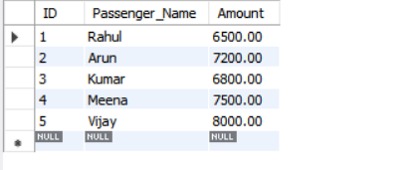
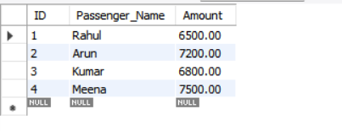
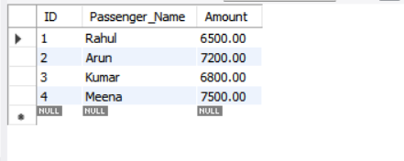

RESULT:
Thus, the TCL commands COMMIT, SAVEPOINT and ROLLBACK were successfully implemented and the results were verified in the Flight Reservation System database.

